
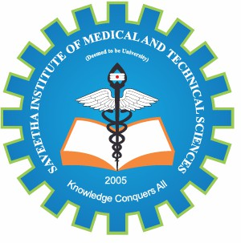
SIMATS ENGINEERING
Saveetha Institute of Medical and Technical Sciences Chennai- 602105
Student Name: N.Nesarajan Reg. No.: 192511386
Course Code: CSA1216 Slot: A
Course Name: COMPUTER ARCHITECTURE
Course Faculty: JERIN SIMLA .A

Project Title: Interrupt-Driven Emergency Response Management System With Bus And Memory Performance Analysis
Module Photographs: (3 photographs –Module Photo, Individual student contribution module work in the project and Presentation image)
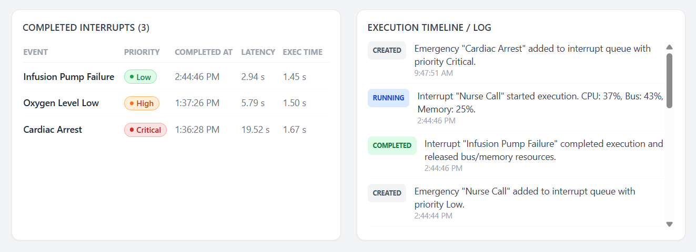
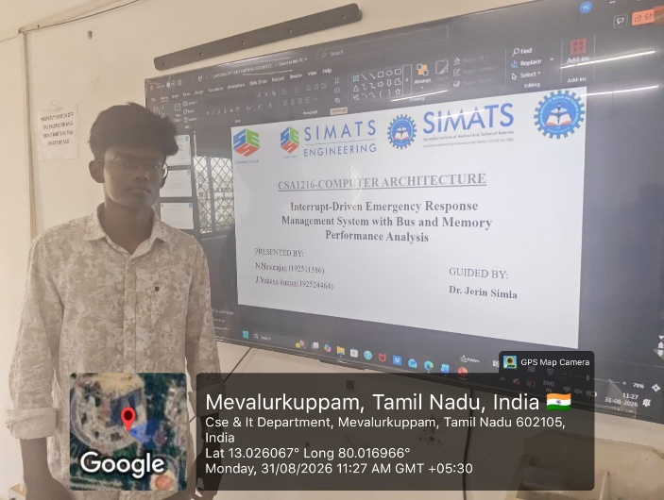
Project Description: (here you write what you did in this project (contribution) including Model Description
The Interrupt-Driven Emergency Response Management System With Bus And Memory Performance Analysis is designed to provide a fast, reliable, and efficient solution for managing emergency situations in real-time systems. The main objective of this project is to use an interrupt-driven approach to detect and process emergency events immediately without continuously checking the status of every device. When an emergency event occurs, the corresponding interrupt is generated and sent to the processor, allowing the system to respond quickly to critical situations. Different emergency events can be assigned different priority levels so that highly critical events are handled before normal or less important tasks. The system focuses on reducing response latency and improving the overall efficiency of emergency event processing.The project also analyzes memory performance by studying memory access time, read and write operations, memory utilization, and the effect of memory delays on emergency response.. Overall, the project demonstrates how efficient interrupt handling, priority-based processing, optimized bus communication, and effective memory utilization can work together to create a responsive and dependable emergency management system.

Student Signature Guide Signature

